**Embedding & Vector Databases/Stores**

Manage and query embeddings which maps different data types into a common vector space, including practical consideration for production deployment.

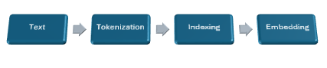

**Vector Search**

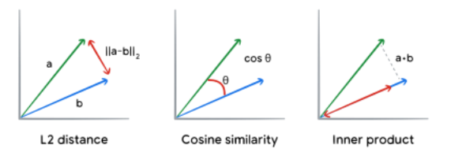

RAG – Document Question and Answering

Consider the list of documents and add to chroma databases.

* **Gemini family** of model **"models/text-embedding-004"** can be used to created embeddings.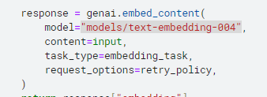

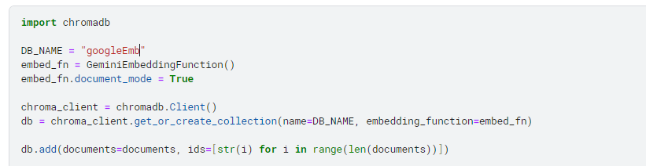

## **Retrieval: Find relevant documents**

Query the embeddings through chroma databases.

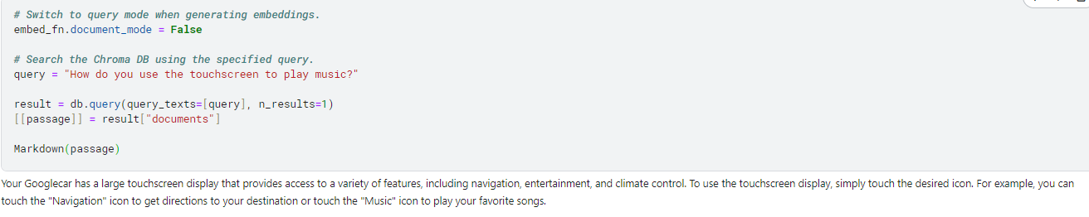

## **Augmented generation: Answer the question**

Finding relevant passage from the set of documents and return response with guided prompt to the model.

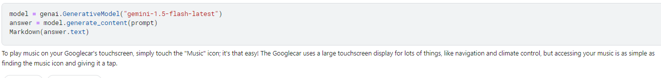

Query **PDF** text documents, specific **tables using sql** **and python** to retrieve specific information from documents through LLMs.